CHRIST’S PROMISE UNITED CHURCH OF CHRIST
May 9, 2021
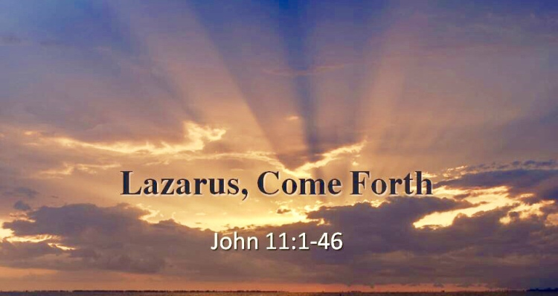

CALL TO WORSHIP
ISN’T THE LOVE OF JESUS SOMETHING WONDERFUL
Isn’t the love of Jesus something wonderful,
Wonderful, wonderful;
O isn’t the love of Jesus something wonderful!
Wonderful it is to me.

UNISON WELCOME
No Matter Who You Are Or Where You Are On Your Life’s Journey, You Are Welcome With Us.

OPENING WELCOME AND UNISON PRAYER:
Almighty God, Alpha and Omega, Jesus Christ the author and finisher of our faith through the comfort and power of the Holy Spirit. We invite you to start today with us, we cannot do anything except your presence comes. Come, oh Lord, with your spirit and fill this place with your glory. Accept our worship and praises. Let everything we do today be divinely orchestrated from heaven. Let the manifestations of power be released upon us. Open the windows of heaven and bless us abundantly and let your joy overflow us all through the day of our lives. In your Lovely Name we pray this, Amen.

Unison Opening Prayer : Spanish
Dios Todopoderoso, Alfa y Omega, Jesucristo el autor y completador de nuestra fe a través del consuelo y el poder del Espíritu Santo.Te invitamos a empezar hoy con nosotros, no podemos hacer nada sin su presencia. Ven, oh Señor, con tu espíritu y llena este lugar de tu gloria. Acepta nuestra adoración y alabanzas. Que todo lo que hacemos hoy sea orquestado divinamente desde el cielo.Que las manifestaciones de poder sean liberadas sobre nosotros. Abre las ventanas del cielo y bendícenos abundantemente y deja que tu gozo nos desborde todos los días de nuestra vida. En tu hermoso nombre rezamos esto, Amén.
CONGREGATIONAL HYMN
OUR GOD REIGNS
How lovely on the mountains are the feet of him,
Who brings good news, good news.
Announcing peace, proclaiming news of happiness.
Our God reigns; our God reigns!

Chorus:
Our God reigns! Our God reigns!
Our God reigns! Our God reigns!

Out of the tomb He came with grace and majesty;
He is alive, He is alive.
God loves us so; see here His hands, His feet, His side.
Yes, we know, He is alive.
FIRST SCRIPTURE READING- Isaiah 52:7-10 (NIV)
⁷How beautiful on the mountains are the feet of those who bring good news, who proclaim peace, who bring good tidings, who proclaim salvation, who say to Zion, "Your God reigns!" ⁸Listen! Your watchmen lift up their voices; together they shout for joy. When the LORD returns to Zion, they will see it with their own eyes. ⁹Burst into songs of joy together, you ruins of Jerusalem, for the LORD has comforted his people, he has redeemed Jerusalem. ¹⁰The LORD will lay bare his holy arm in the sight of all the nations, and all the ends of the earth will see the salvation of our God.

PRAISE AND WORSHIP

Let It Rise
Let The Glory Of The Lord, Rise Among Us
Let The Glory Of The Lord, Rise Among Us
Let The Praises Of Our King, Rise Among Us
Let It Rise

Let The Songs Of The Lord, Rise Among Us
Let The Songs Of The Lord, Rise Among Us
Let The Joy Of Our King, Rise Among Us
Let It Rise

Oh, Oh Oh, Let It Rise
Oh, Oh Oh, Let It Rise

Trading My Sorrows
I'm trading my sorrows
I'm trading my shame
I'm laying them down
For the joy of the Lord
I'm trading my sickness
I'm trading my pain
I'm laying them down
For the joy of the Lord
Vamp
Yes Lord yes Lord yes yes Lord
Yes Lord yes Lord yes yes Lord
Yes Lord yes Lord yes yes Lord amen
Verse
I am pressed but not crushed
Persecuted not abandoned
Struck down but not destroyed
I am blessed beyond the curse
For His promise will endure
And His joy's gonna be my strength
Though sorrow may last for the night
His joy comes in the morning
{back to chorus}

Healing Stripes
Oh Lord We Love You
And We Gather In Your Name
Oh Lord We Love You
Now and Forever the Same
{Repeat}
We Reach To Heaven and Glorify Your Name
We Celebrate You Jesus for the Grave You Overcame
You Shed Your Blood to Save Us
And Forever Set Us Free
You Bore Stripes to Heal Us
We Will Forever Worship Thee

PRAYERS OF THE PEOPLE
STEWARDSHIP/OFFERING/ANNOUNCEMENTS

SERMON SCRIPTURE READING –John 11:38-44

Jesus Raises Lazarus From the Dead
³⁸ Jesus, once more deeply moved, came to the tomb. It was a cave with a stone laid across the entrance. ³⁹ “Take away the stone,” he said. “But, Lord,” said Martha, the sister of the dead man, “by this time there is a bad odor, for he has been there four days.” ⁴⁰ Then Jesus said, “Did I not tell you that if you believe, you will see the glory of God?” ⁴¹ So they took away the stone. Then Jesus looked up and said, “Father, I thank you that you have heard me. ⁴² I knew that you always hear me, but I said this for the benefit of the people standing here, that they may believe that you sent me.” ⁴³ When he had said this, Jesus called in a loud voice, “Lazarus, come out!” ⁴⁴ The dead man came out, his hands and feet wrapped with strips of linen, and a cloth around his face. Jesus said to them, “Take off the grave clothes and let him go.”
SERMON (Pastor Mel) “Out Of The Grave”
Lazarus was in the grave. Jesus waited a few days before showing up on the scene and exerting His resurrection Power. Although we don’t see many resurrections from the grave these days… we do see many people in places of darkness and despair that are called out of the grave to abundant and fulfilled life. What grave are YOU in today?

COMMUNION

POST COMMUNION – SING “THE LORD’S PRAYER”

CLOSING HYMN

SUNSHINE IN MY SOUL
There is sunshine in my soul today
More glorious and bright
Than glows in any earthly sky;
For Jesus is my light.

Chorus:
O there’s sunshine, blessed sunshine,
When the peaceful, happy moments roll;
When Jesus shows His smiling face,
There is sunshine in my soul.

There is music in my soul today,
For when the Lord is near
The dove of peace sings in my heart;
The flow'rs of grace appear.

There is gladness in my soul today,
And hope and love and praise,
For blessings which He gives me now,
For joys in future days.
Thanks for Joining us Today in
Worship & Praise!

Rev Mel Wilkinson – Pastor
813-833-1952
pastormelwilkinson@gmail.com
Worship Team:
Rodney Charles (Music Director)
Ashley Cooper (Choir Director)
Ken Brower (Tenor)
Steven Blansfield (Baritone)
Gary McQuaig (Guitarist)
Cookie McQuaig (Bass)

Technical Specialists:
Robert Blansfield
Freda Clark
.

